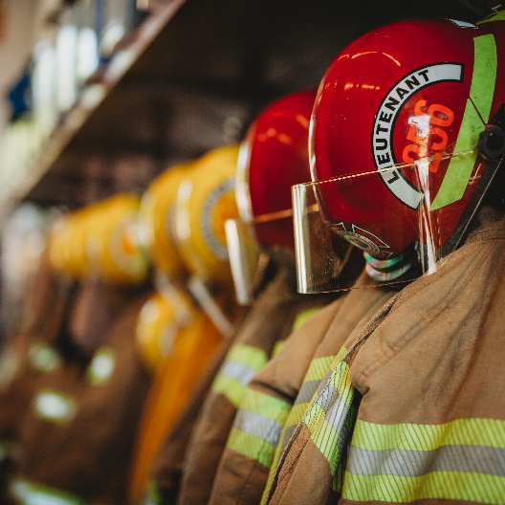
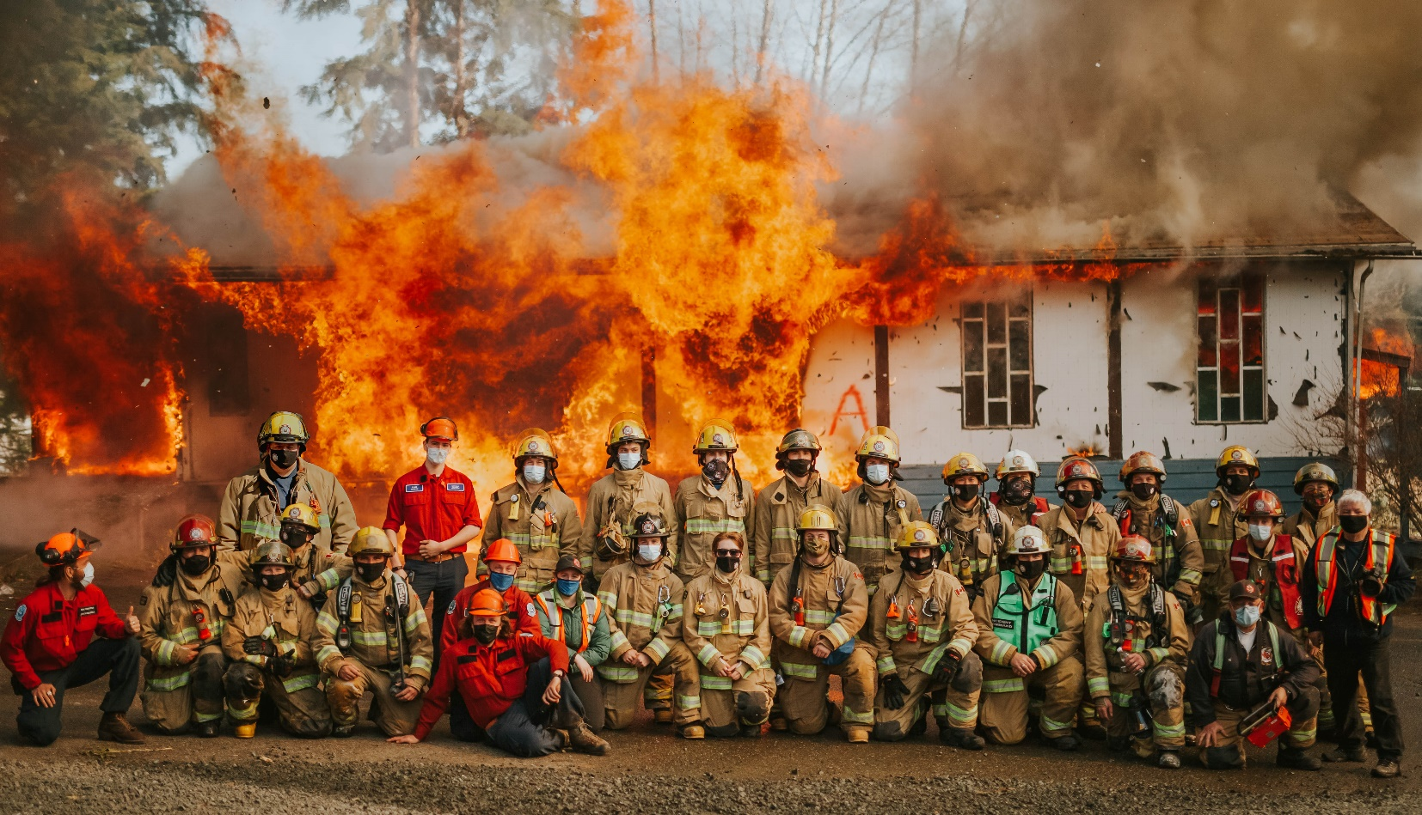
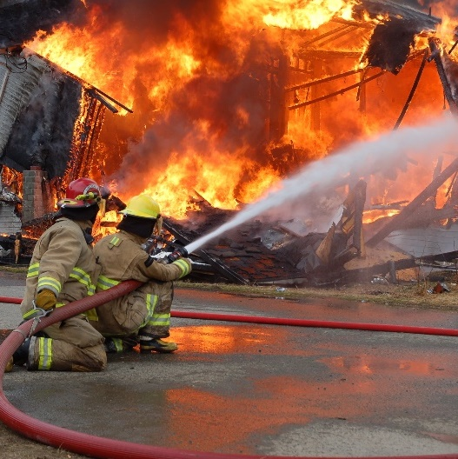
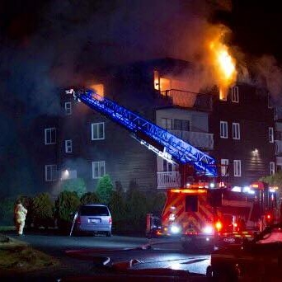
We acknowledge, with respect and gratitude, that we live, serve, and play on the Traditional Territories of the Kwakwaka’wakw Peoples, and we humbly honour their abiding connection to these lands.
Recruitment and Orientation Guide for Applicants
Updated June 2022
www.porthardyfire.ca | 8890 Central Street, Port Hardy, BC | (250) 230-0341
Photo: kph photography
Port Hardy Fire Rescue
Table of Contents
Join Our Team 3
Role of a Firefighter 4
About this Guide 5
How to Apply 5
General Information 6
Compensation 6
Who Are We Looking For? 7
Roles, Responsibilities, and Expectations 8
Qualifications Checklist 9

for more information:
Fire Chief Brent Borg Deputy Chief Gavin Texmo
T 250.230.0341 T 250.902.8147
E firechief@porthardy.ca E deputychief@porthardy.ca
PO Box 68, 8890 Central Street, Port Hardy BC, V0N 2P0 | porthardyfire.ca
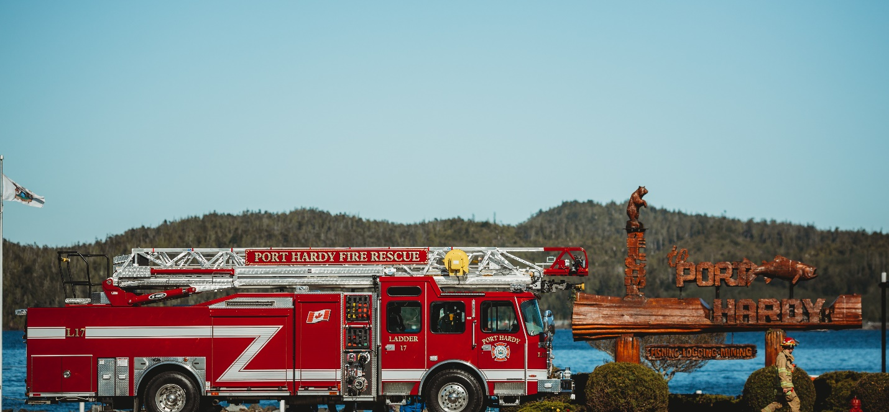

Join Our Team
It takes a special person to fill the boots of a volunteer firefighter. Someone with a desire to do something important for their community. Someone with courage and dedication who isn’t afraid of hard work, and who is willing to accept the challenge of a difficult job. It takes a person who considers respect and appreciation reward enough, and who is just glad to help. If you’re this kind of person, you’re needed as a volunteer firefighter.
Port Hardy Fire Rescue is seeking men and women to join our ranks, to serve and protect their community as firefighters. Port Hardy Fire Rescue is an integral organization of the District of Port Hardy, and we invite qualified candidates to join our team and help us with the important work we do.
MISSION STATEMENT
To provide the citizens of Port Hardy with proactive, effective, and efficient delivery of fire, rescue, public education and fire prevention services, through a unified, forward-thinking organization with good morale and with the highest standards of personnel safety, fairness, and professionalism.

Role of a Firefighter
Firefighting is one of the most diverse and challenging professions in the world today, and there is far more to the job of a firefighter than just extinguishing fires. Firefighters respond to a wide range of emergency situations where they protect people, property, and the environment. These emergencies often include numerous hazards, and this coupled with the fact that a firefighter’s skills may be needed any time of day or night, seven days a week, and in any weather conditions, often under potentially stressful and emotional circumstances, makes our contribution very rewarding.
Volunteering as a firefighter with Port Hardy Fire Rescue means ensuring continuous learning: practice nights, weekend training, lectures, pre-incident planning, exercises, down-island training with other departments, and hall duty mornings are all part of the job.
Becoming a firefighter is not for everyone. You need more than just a desire to help people; you also require courage, dedication, assertiveness, and a willingness to learn new skills and face new challenges. Our service is one that calls upon members to perform strenuous work in uncertain and hazardous environments as a highly efficient team.
However, the personal rewards and satisfaction received from being a firefighter are often beyond description. There is a deep sense of accomplishment after controlling a structure fire, compassion for accident victims, and fulfillment in teaching fire safety. The list could go on.
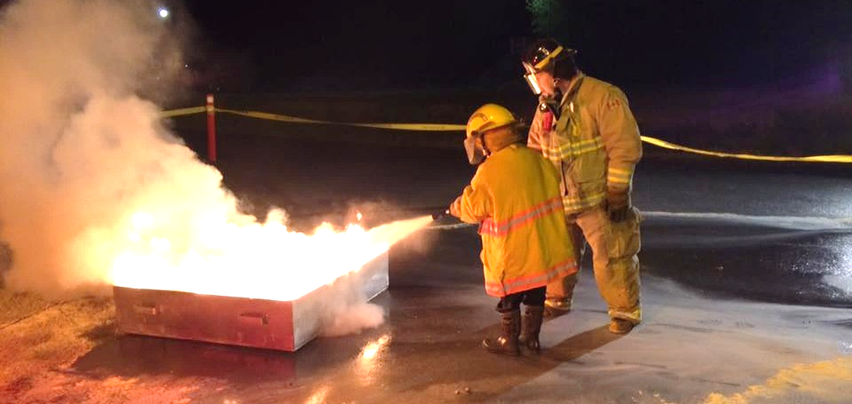
The bottom line in our business is measured by the prevention and reduction of loss of life, pain and suffering, and property damage throughout our municipal area. We strive to maintain a professional image while providing a safe, reliable, and cost-effective service to the residents of our community.

About this Guide
This handbook has been developed as a resource for those interested in becoming a firefighter with Port Hardy Fire Rescue and outlines the basic structure of the department, the roles and responsibilities of firefighters with Port Hardy Fire Rescue, information on training and participation requirements, answers to some typical questions often raised by prospective members, and information on how to apply and join our ranks.

How to Apply
Applications to become a firefighter with Port Hardy Fire Rescue are accepted year-round. There is no specific applicant intake period for Port Hardy Fire Rescue.
An application form may be found at the back of this guide and should be completed in full by all applicants.
All prospective candidates must meet the basic minimum qualifications to be considered for application to Port Hardy Fire Rescue. Please see the qualifications checklist contained within this guide for details.
Prospective candidates who meet all the basic qualifications are invited to submit an application and the required documentation:
- By email: firechief@porthardy.ca or deputychief@porthardy.ca
- By mail: Port Hardy Fire Rescue, PO Box 68, Port Hardy BC, V0N 2P0
- In person:
  - District of Port Hardy Municipal Office:
7360 Columbia St., Port Hardy (Monday to Friday 8:30am-4:30pm)
  - Port Hardy Fire Rescue Hall No. 1:
8890 Central St., Port Hardy (Thursdays 7:00pm-9:00pm or by prior appointment with the Fire Chief)
All applicants are required to participate in an interview with the Fire Chief. If accepted, all new recruits must work towards meeting basic training benchmarks, as directed and assisted by the training officers.
If you have any questions about the application process, please contact Fire Chief Brent Borg at 250.230.0341 or email firechief@porthardy.ca or Deputy Chief Gavin Texmo at
250.902.8147 or email deputychief@porthardy.ca
For more information about Port Hardy Fire Rescue, visit www.porthardyfire.ca.
We are an equal-opportunity organization and welcome all qualified individuals to apply.

General Information
Port Hardy Fire Rescue was established in 1968, originally with two separate departments, one serving the central Port Hardy area, and the other serving the Storey’s Beach area. Later amalgamated to operate as a single department with two halls, Port Hardy Fire Rescue strives to maintain a full roster of 30 members. Annually, Port Hardy Fire Rescue responds to approximately 150-200 emergency calls, ranging from firefighting to road rescue and other emergency response services within the District of Port Hardy and the remainder of the North Island area through mutual aid and fire service agreements. With a fleet of six apparatus including two engines, two rescue trucks, an aerial ladder, and a command vehicle, Port Hardy Fire Rescue is the busiest fire department on the North Island.
All emergency calls are dispatched through North Island 911 Corporation and the Campbell River Fire Dispatch Centre. All firefighters are required to carry a department-supplied pager 24/7, as well as use a smartphone digital notification application. When a page-out is initiated, members respond directly to their respective fire hall for further instruction and response.
Port Hardy Fire Rescue operates using a personnel rank system and the chain of command. The Fire Chief is the top-ranked position in the department, and the Fire Chief is ultimately responsible for the governance of the entire department. Officers, including Captains and Lieutenants, provide day-to-day operational direction and support, while Firefighters perform all regular duties. Rookie Firefighters are those who have completed basic training but are still relatively new with the department and operate under direct supervision from more senior members. Recruit Firefighters are those who have just joined and are undergoing basic minimum training.
Applications to join Port Hardy Fire Rescue are accepted year-round. All applicants must meet the eligibility criteria identified within this guide, participate in an interview, and work towards meeting basic training benchmarks, as directed and assisted by training officers, if accepted.

Compensation
Port Hardy Fire Rescue is a paid-on-call department: members receive basic compensation for attendance at emergency calls, scheduled training, and scheduled hall duties. Port Hardy Fire Rescue also covers all expenses for training, travel, equipment, and required personal gear.
All members, while participating in training, duties, and emergency calls, are covered by WorkSafeBC in the event of injury or death. All members are also entitled to a group-insurance accidental death and dismemberment and disability policy.
All members are also encouraged to join the Port Hardy Volunteer Firefighters Association, a not-for-profit organization representing the interests of the Port Hardy Fire Rescue membership. The PHVFA plans numerous family social events throughout the year.
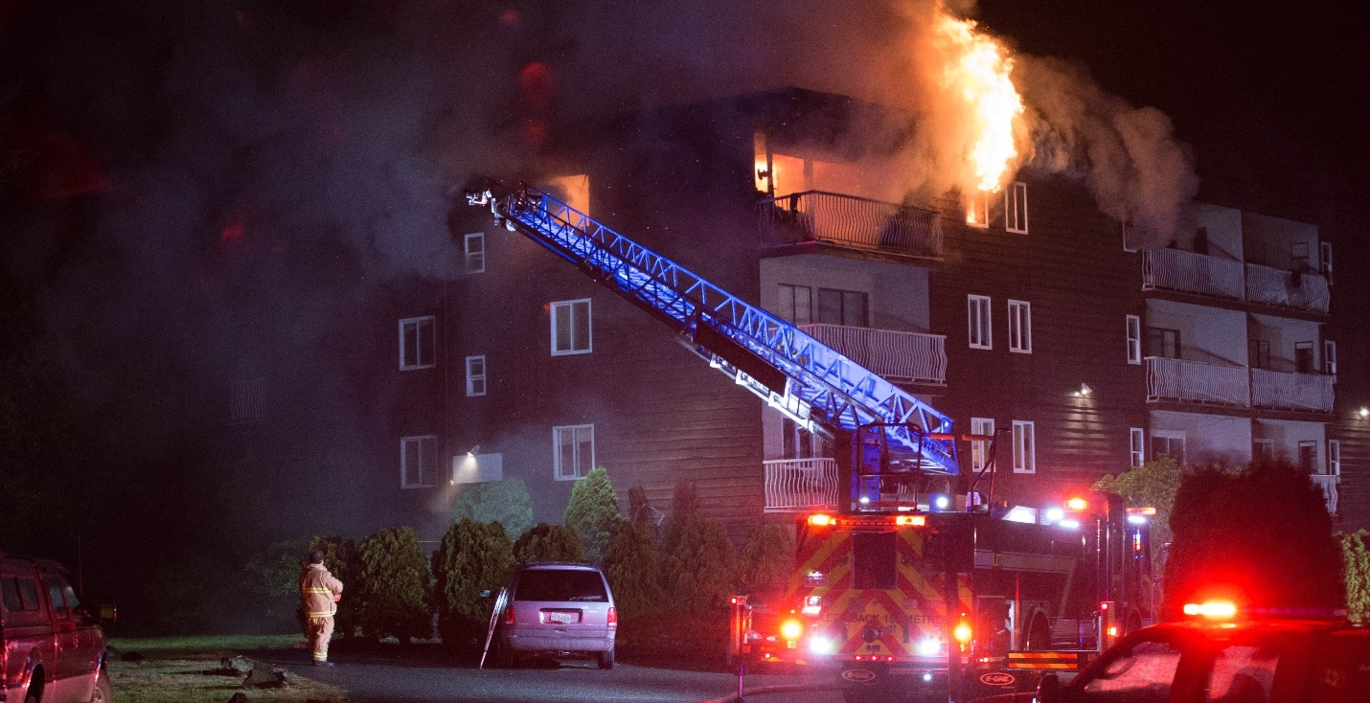
Photo: Karen Ewald Photography

Who Are We Looking For?
We consistently strive to maintain a membership base of diverse background, skills, training, and experience. The following list details some of the experience areas that we look for in our candidates. These items are not requirements but should be considered assets for applicants.
- Previous experience as a firefighter
- Non-smoker and physically fit
- Skilled in operating and maintaining heavy equipment and/or commercial vehicles (BC Class 1 or Class 3 driver’s license)
- Skilled in the maintenance and operation of hand tools, power tools, and portable equipment
- Ability to operate communications equipment
- Mechanically Inclined
- Experience with information technology systems and applications
- Strong written and technical communication ability
- Knowledge of District of Port Hardy geography, location of streets and buildings
- Apprenticeship or trade certification
- Familiarity with local logging roads
- Proven ability to work in a team environment
- Volunteer work in the community
- Commitment to continuous learning
Please review the Qualifications Checklist near the end of this guide for details on the mandatory minimum requirements to apply to join Port Hardy Fire Rescue.

Roles, Responsibilities, and Expectations
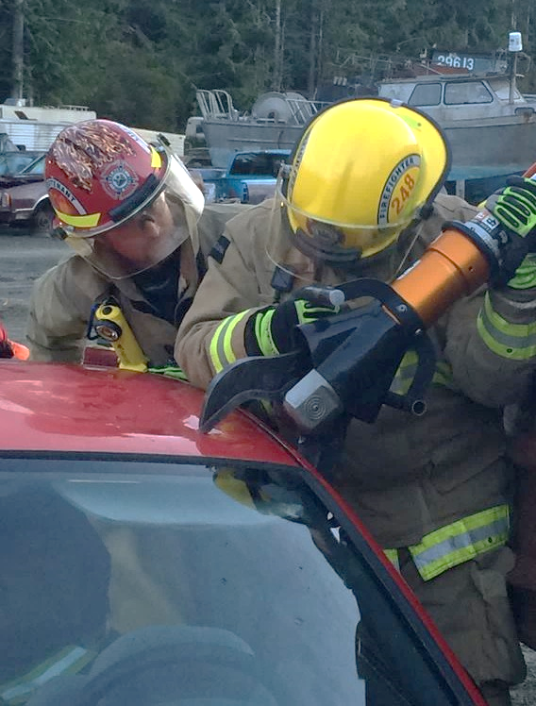
The decision to join Port Hardy Fire Rescue and become a firefighter must not be taken lightly. Between training, emergency calls, and other responsibilities, becoming a member is a significant time commitment, and requires discussion with others in your personal and work life prior to joining. Your family must support your decision. They must understand and accept your commitment to training, and that responding to emergencies at all times of the day or night will often interrupt family functions. Your employer should also be accepting of your commitment to the department, and understand that responses to emergencies outside working hours could occasionally interfere with one’s work performance (e.g. a response at 2am may lead to fatigue the next day at work). As work should remain a priority for all members, prospective members are encouraged to discuss their decision to become a firefighter with their employer prior to joining.
If accepted to join the department, firefighters are expected to fulfill the following mandatory duties:
- Read, understand, and sign-off on all Port Hardy Fire Rescue Operational Guidelines which govern all operations of the department and its personnel.
- Participate and satisfactorily complete a basic minimum training program as directed by training officers prior to further participation in routine training and emergency calls.
- Participate in a minimum of 70% of all regularly scheduled training, and 100% of all hall duties (approximately one Sunday morning (3hrs) every 6 weeks).
- Once approved by the Fire Chief, respond to fire, rescue, and other emergency calls, and perform all duties as directed by the incident commanding officer.
- Perform in-station duties as assigned, including routine and unscheduled maintenance of apparatus, portable and fixed tools and equipment, and routine maintenance at fire stations including cleaning and housekeeping.
- Maintain and demonstrate a professional appearance and attitude to the public and within the community, during and outside of Port Hardy Fire Rescue activities.

Qualifications Checklist
Below is a checklist to assist you in submitting your application to Port Hardy Fire Rescue.
ALL qualifications must be met and additional documentation, where required, included. Photocopies of additional documentation, or scanned files if emailing your application, are accepted.
Minimum criteria for application:
- Be at least 18 years of age and be legally employable in BC
- Have completed high school, or have equivalent education and experience
- Be available Thursday nights from 7pm-9pm to attend weekly training nights
- Have a suitable means to get to the fire hall for an emergency response
- Obtain a criminal record check (including a vulnerable sector check) with no indication of a criminal record that would adversely affect public trust
- If you have a driver’s license, obtain a copy of your driver’s abstract from ICBC, with a driving record indicative of responsible motor vehicle operation
- Reside within a proximity to Port Hardy that enables a timely response to Fire Hall No. 1 or No. 2 for an emergency dispatch
- Submission of a completed PHFR Firefighter Application Form
* Please speak to the Fire Chief for specific minimum qualifications for the junior firefighter program.
Once an application has been submitted, potential candidates may be invited for an interview with the Fire Chief. Completion of an interview does not guarantee applicants a position with Port Hardy Fire Rescue. The Fire Chief reserves the right to accept applicants at his or her discretion. Not all applicants will necessarily be successful.

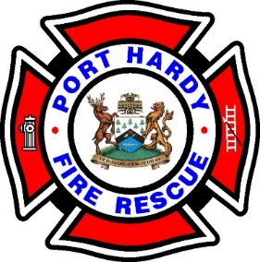
8890 Central Street
Port Hardy, BC
V0N 2P0

www.porthardyfire.ca
Intentionally left blank.

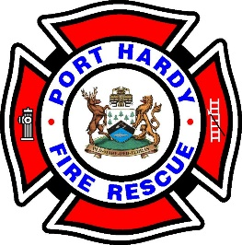 | Port Hardy Fire Rescue  PO Box 68, 8890 Central St.  Port Hardy BC, V0N 2P0  phone: 250-230-0341  fax: 250-949-6572  email: firechief@porthardy.ca

Port Hardy Fire Rescue – Firefighter Application Form

Date: _____________________________

- PERSONAL INFORMATION

Name: _______________________________________________________________________
(Last Name) (Given Names in Full) (Nick Name)

Email: ______________________________ Phone #: _________________________

Date of Birth: ______________________________________
(Day) (Month) (Year)

Are you legally eligible to work in Canada? ____________

Education: (circle last year completed) 8 9 10 11 12 13

Certificates or Diplomas: _________________________________________________________

Do you have any First Aid training? Yes £ No £ If so what level: ______________________

- EMPLOYMENT INFORMATION

Are you presently employed? Yes £ No £

Occupation: __________________________________________

Employer / Company’s Name: __________________________

Address: ____________________________________________________________________

Telephone #: ______________________

Will your employer allow you to respond to emergency calls while at work? Yes £ No £

- FIRE SERVICE HISTORY

What is your reason for applying with Port Hardy Fire Rescue? ___________________________

______________________________________________________________________________

______________________________________________________________________________

______________________________________________________________________________

Have you any previous experience with the Fire Service? Yes £ No £

If “Yes”:

When: ________________________________________________________________________

Where: _______________________________________________________________________

- MEDICAL INFORMATION

Have you had any serious illnesses or injuries in the last five years? If so, please describe and provide any work limitations: ______________________________________________________

______________________________________________________________________________

Do you have any impairments of sight, hearing, speech and/or physical disabilities? If yes, please describe: ________________________________________________________________

______________________________________________________________________________

Do you have any known allergic reactions to smoke, poison ivy/oak, insect stings, etc.? If so, please describe: ________________________________________________________________

______________________________________________________________________________

Have you had a Hearing Test in the past 12 months? Yes £ No £

If “Yes” When__________________ Where______________________________

- DRIVER’S LICENSING INFORMATION

Name as seen on driver’s license: __________________________________________________
(Last Name) (Given Names in Full)

Driver’s License #: _________________ Do you own a vehicle? Yes £ No £

What class is your license? 1 £ 2 £ 3 £ 4 £ 5 £ 6 £ 7 £ 8 £

Restrictions: ___________________ Endorsements: ___________________

- CONDITIONS OF VOLUNTEERISM

I affirm and certify that the information given on, or attached to this application, is true and correct. I understand that any falsification of statements, misrepresentation, deliberate omission, or concealment of information may be considered just cause for immediate dismissal.

I authorize Port Hardy Fire Rescue to annually check my driver’s abstract or confirm any information in this application.

Date: ________________________ Signature of applicant: ______________________

Personal information on this form is collected under the authority of the Freedom of Information and Protection of Privacy Act [RSBC 1996] c. 165, and will be used to assess qualifications for volunteerism with the District of Port Hardy. Questions about this collection of information should be directed to the Fire Chief, Port Hardy Fire Rescue, 8890 Central Street, Port Hardy BC, 250-230-0341.

Port Hardy Fire Rescue
PO Box 68, 8890 Central St.
Port Hardy BC, V0N 2P0
phone: 250-230-0341
fax: 250-949-6572
email: firechief@porthardy.ca

FIRE CHIEF INTERVIEW COMMENTS AND ACCEPTANCE INFO (OFFICE USE ONLY)

Remarks of interviewing officer: ___________________________________________________
______________________________________________________________________________
______________________________________________________________________________
______________________________________________________________________________
______________________________________________________________________________
______________________________________________________________________________
______________________________________________________________________________
______________________________________________________________________________

Height ___________ Weight ___________ Shoe Size ________ Shirt Size_____

Emergency Contact Name: ________________________________________

Address: ______________________________________________________________________
(Street Address) (Town/City)

Telephone #: _______________________ Relationship: ______________________________

Criminal record check: Attached £ To Follow £ Received £

Driver’s abstract: Attached £ To Follow £ Received £

Application form: Complete £ To Follow £ Received £

Date of acceptance: _____________________ Date of termination: ___________________

Approved by Fire Chief (signature): ___________________________ Date: _____________

MEDIA RELEASE (to be completed after acceptance)
By signing this Media Release, I hereby consent for photographs / video of myself to be used by Port Hardy Fire Rescue, the District of Port Hardy, and / or the Port Hardy Volunteer Firefighters Association for promotional, media, and reporting purposes. This includes the occasional use of my photo on the official social media accounts of Port Hardy Fire Rescue and / or the District of Port Hardy as well as the websites of Port Hardy Fire Rescue and / or the District of Port Hardy.

Name (please print): _________________________________________________

Address: __________________________________________________________

Telephone No.: _(_______)___________-____________________

Signature: ____________________________________

Parent/Guardian Signature (if under 19): _________________________________

Date (mm/dd/year): _______/_________/___________________
FITNESS ACKNOWLEDGEMENT (to be completed after acceptance)
I understand that certain risks are inherent to firefighting, and that a certain level of physical and mental fitness must be maintained to perform effectively and keep myself and my fellow members safe during operations. I am aware of my personal level of physical and mental fitness and my personal health situation, including any limitations in my health that I may have that may limit my ability to perform as a firefighter, and/or may jeopardize the safety of myself and/or my fellow member. I understand that it is my responsibility to maintain my fitness and health to an appropriate level, and that any concerns or limitations have been discussed with my physician or health practitioner.

Name (please print): _________________________________________________

Address: __________________________________________________________

Telephone No.: _(_______)___________-____________________

Signature: ____________________________________

Parent/Guardian Signature (if under 19): _________________________________

Date (mm/dd/year): _______/_________/___________________

